************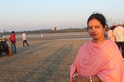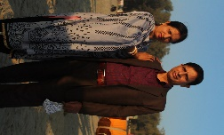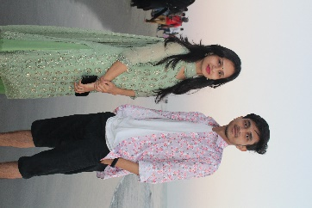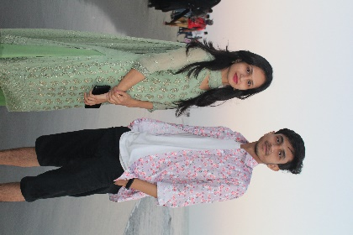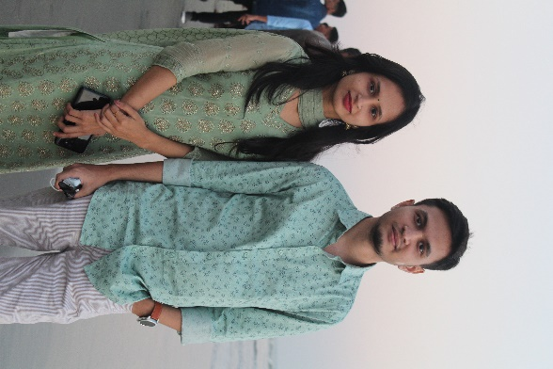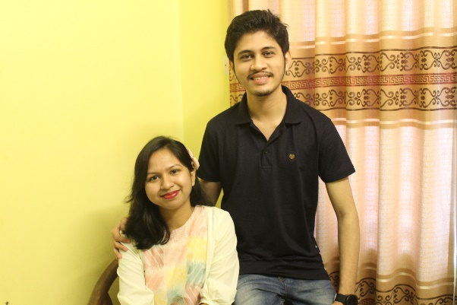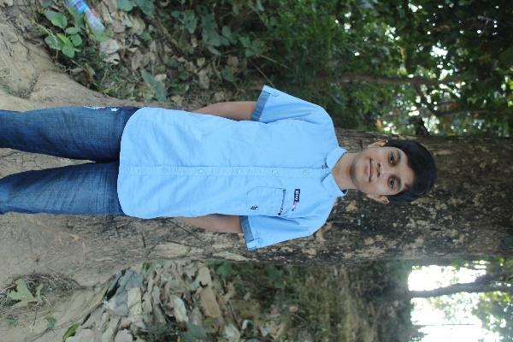***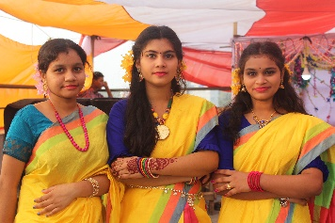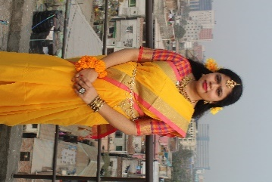******MY FAMILY TREE***

UNCLE- BABUL BHOWMIK

AUNT- RAKHI BHOWMIK

AUNT – PROMILA BISWAS

COUSIN – RUDRA BHOWMIK

COUSIN – BONNI BHOWMIK

COUSIN – ADITI SARKER

COUSIN- ADITTAYA SARKER

FATHER – PARIMAL BISWAS

**MOTHER SIDE FATHER SIDE**

GRANDFATHER- LATE JOTI SARKER

GRANDMOTHER- SOMOTI SARKER

GRANDMOTHER- LATE SHANTA BISWAS

S

GRANDFATHER- LATE NIRANJAN BISWAS

MOTHER- SHAKHI BISWAS

BROTHER- PIYAS BISWAS

**ME – RIPA RANI BISWAS**

SISTER- PINKY RANI BISWAS

COUSIN – BABUL SARKER

COUSIN – BADAL SARKER

COUSIN – MONI SARKER

COUSIN – SANOY SARKER

COUSIN – PRONOY SARKER

COUSIN – TANMOY SARKER

COUSIN – ARNAB SARKER

COUSIN – SARAN DAS

COUSIN – RATRI BISWAS

COUSIN – PRITAM BISWAS

COUSIN – SORNA BISWAS

COUSIN – DRUBA BISWAS

COUSIN – PRANTA SARKER

COUSIN – PORNA BISWAS

AUNT – ARPITA SARKER

AUNT – AMRITA SARKER

AUNT – LIPI SARKER

UNCLE – NANI SARKER

UNCLE – NIKHIL SARKER

UNCLE – NAKUL SARKER

AUNT-DIPTI BISWAS

UNCLE-DIPAK BISWAS

AUNT-RINA BISWAS

UNCLE – PRABITRA BISWAS

UNCLE – PRADIP BISWAS

AUNT – BINA BISWAS

AUNT – DIPIKA DAS

UNCLE – SRIJIB DAS

COUSIN- SREYA MAJUMDER

COUSIN- JOY MAJUMDER

COUSIN- MANIK MAJUMDER

UNCLE – RATAN MAJUMDER